

Calorify AI – (AI Nutrition Coach)

Rahaman Mohammad

24/04/2026

A project report submitted in partial fulfilment of the degree of
Master of Science in Data Science and Artificial Intelligence
School of Computing and Creative Industries
Leeds Trinity University

Abstract
The increased incidence of diet-related chronic diseases clearly showed him that many nutritional applications in use are not delivering as much as they could. Most available applications still require manual input of food items, and the level of personalisation and decision support they offer is quite limited. So in this project, the development of Calorify AI- an intelligent nutritional system that can offer automated, personalised, and context-aware dietary advice, using the combination of computer vision, nutritional modelling, and behavioural analysis.
The image classification system is built using a deep learning model implemented with transfer learning on a resnet-based architecture. A nutritional estimate is computed using a hybrid of a trained local dataset and weight-based estimations to obtain the Calorie and macronutrient estimates for the respective food item. The personal model, designed using user features such as age, weight, activity levels, and specified goals, provides a nutritional target unique to each user. We also incorporated sleep, activity, and hydration into our advice to provide context-based guidance.
The model was evaluated using accuracy, F1 score, and ROC AUC. They showed that the model performs consistently and generalises well to unseen data. We added Top-K predictions and confidence scores to make the predictions easier for the user to understand. I evaluated the model using standard metrics such as accuracy, F1 Score, and ROC AUC. Overall, the results suggest that it performs consistently and generalises well to new, unseen data. The performance metrics were evaluated using standard metrics such as accuracy, F1-score, and ROC-AUC, indicating good performance and generalisation. I also added features such as Top-K prediction and a confidence score to make the output more understandable for the user and help build more trust in the model. Such problems are associated with constraints in the general domain of computer vision-based diet monitoring and highlight areas for improvement through better models and the integration of multiple data modalities.
The project highlights the potential for AI in revolutionising digital nutritional systems- moving from tracking food intake to offering intelligent, personalised, and context-aware support to achieve a user's nutritional goals. The system developed in this project is highly scalable and has the potential to be further improved, serving as the backbone of a new generation of AI-driven health systems.

Attestation
I understand the nature of plagiarism and other uses of unfair means. I am aware of and have adhered to the university’s policy on this.

- This assignment used generative AI in the following ways for the purposes of completing the assignment: brainstorming, research, planning, feedback, and editing.

Example of using AI ( Screenshot)
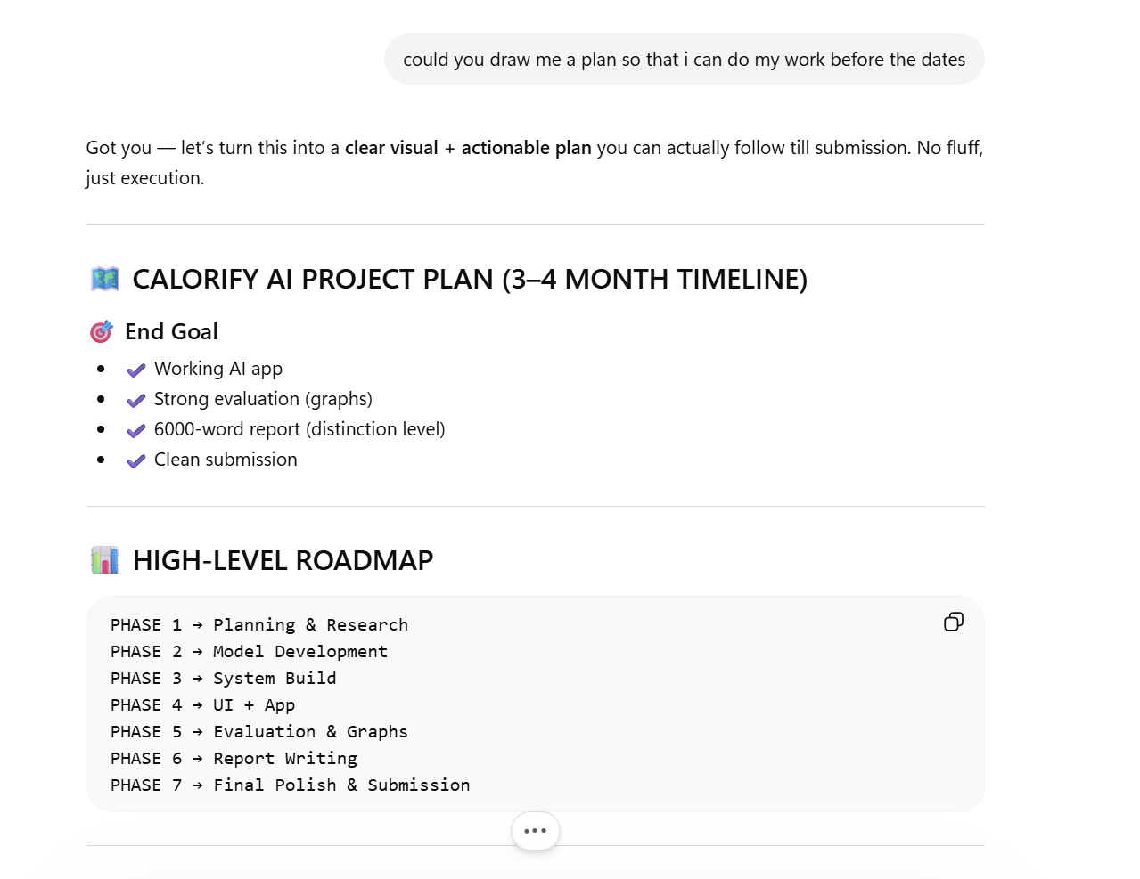

Acknowledgements
I want to express my sincere gratitude to my supervisor and the academic staff at Leeds Trinity University for their guidance and support throughout the development of this project. Their comments and suggestions have helped me not only with the analytical but also with the technical implementation of this project.
The opportunity and resources provided by the university to delve into complex topics in Data Science and Artificial Intelligence have also been much appreciated.
Finally, I would like to acknowledge the open-source community and publicly available datasets and tools, including the Food-101 dataset and Open Food Facts, which played a significant role in the successful completion of this project.

Table of Contents
Table of Figures 9
Table of Tables 9
1. Introduction 10
1.1 Introduction 10
1.2 Research Context 11
1.3 Overview of the Research Work and Rationale 11
1.4 Aim and Project Objectives 12
1.5 Research Questions 12
1.6 Chapter summary 13
2. Literature Review 13
2.1. Introduction 13
2.2. Food Image Recognition and Computer Vision Foundation 13
2.2.1. Deep Convolutional Neural Networks Vision Foundations 13
2.2.2. Transfer Learning for Food Recognition 14
2.3. Nutrition Estimation and Health Applications 14
2.3.1. Combining Image, Text, and User Input 15
2.3.2. Human – Centred Interaction in Intelligent Food Applications 16
2.4. Limitations of Existing Systems 16
2.4.1. Calorie and Macronutrient Estimation Approaches 16
2.4.2. BMI, BMR, and Goal-Based Personalisation 17
2.5. Behavioural Analytics and AI Decision Support in Health Applications 17
2.5.1. Sleep, Activity, Hydration, and Weight Tracking 18
2.5.2. Intelligent Feedback and Recommendation Systems 18
2.6. Conceptual Framework 19
2.7. Research Gap 19
2.8. Summary 20
3. Implementation (or Artefact Development) 20
3.1. Introduction 20
3.2. System Design and Application Workflow 20
3.3. Model Implementation 22
3.3.1. Architecture Design 22
3.3.2. Training Strategy 22
3.3.3. Data Handling and Pipeline 23
3.3.4. Data Augmentation 23
3.3.5. Handling Class Imbalance 23
3.4. Model Evaluation Implementation 23
3.5. Prediction and Inference System 24
3.5.1. Model Loading 24
3.5.2. Inference Pipelines 25
3.5.3. Test-Time Augmentation (TTA) 25
3.5.4. Confidence-Based Decision System 25
3.6. Nutrition Engine Implementation 28
3.7. Personalisation Module 28
3.8. Database and Data Management 28
3.9. User Interface Implementation 29
3.10. AI Insights and Recommendation System 30
3.11. Challenges and Solutions 31
3.12. Summary 32
4. Results 32
4.1. Introduction 32
4.2. Dataset and Evaluation Setup 32
4.3. Overall Model Performance 33
4.4. Classification Performance Analysis 37
4.4.1. Confusion Matrix 37
4.4.2. Classification Report 37
4.5. Top K Accuracy Analysis 37
4.6. ROC Curve and AUC Analysis 38
4.7. Precision–Recall Analysis 39
4.8. Model Calibration and Confidence Analysis 39
4.8.1. Calibration Curve 39
4.8.2. Expected Calibration Error (ECE) 40
4.8.3. Brier Score 40
4.9. Error Analysis 41
4.10. System-Level Evaluation 42
4.11. Comparison with Expected Performance 42
4.12. Limitations of Results 43
4.13. Chapter Summary 43
5. Discussion 44
5.1. Introduction 44
5.2. Achievement of Project Objectives 44
5.3. Strengths of the System 45
5.3.1. Multimodal Integration 45
5.3.2. Strong Predictive Performance 45
5.3.3. Practical Usability 45
5.3.4. Decision-Support Capability 45
5.4. Limitations of the System 45
5.4.1. Visual Ambiguity in Food Recognition 45
5.4.2. Portion Size Estimation 46
5.4.3. Model Calibration 46
5.4.4. Dataset Limitations 46
5.5. Interpretation of Key Findings 47
5.6. Comparison with Existing Approaches 47
5.7. Real-World Applicability 47
5.8. Future Improvements 48
5.9. Reflection on System Design 48
5.10. Chapter Summary 48
6. Conclusion 49
6.1. Summary of the Project 49
6.2. Key Achievements and Contributions 49
6.3. Evaluation of Outcomes 49
6.4. Limitations 50
6.5. Future Work 50
6.6. Final Remarks 51
References 52

Table of Figures
Figure 1: System Architecture 21
Figure 2: Model prediction and confidence 27
Figure 3: System UI 30
Figure 4 Recommendation System 31
Figure 5: Inference Speed Comparison 33
Figure 6 Top-3 Accuracy Comparison 34
Figure 7: Model Size Comparison 34
Figure 8: Training Time Comparison 35
Figure 9: Test Accuracy Comparison 35
Figure 10: Macro F1 Comparison 36
Figure 11: ROC curve 38
Figure 12: Calibration Curve(accuracy x Confidence) 40

Table of Tables
Table 1: System Architecture 21
Table 2: Model prediction and confidence 27
Table 3: Database Tables and Stored Information

Introduction

Introduction
There is an increasing number of illnesses linked to the unhealthy lifestyles people are leading. Therefore, there is an ever-growing need for innovative systems that could monitor diets and adjust nutrition accordingly. However, most existing approaches to calorie counting and related tasks rely too heavily on manual interactions and standard models.
Recent developments in computer vision and data analytics have enabled automatic identification of different foods from their images. Moreover, based on this data, users can receive suggestions for the optimal choice. Still, there is a lack of more advanced approaches to dietary monitoring, including some behaviour analytics.
To fill in this gap, Calorify AI was developed. It uses computer vision algorithms for automatic food identification, along with advanced personalisation and behavioural models, to provide users with meaningful dieting suggestions.

Research Context
The global increase in the number of obese, diabetic and other patients with health issues related to their nutrition is putting pressure on healthcare organisations and reinforcing the importance of implementing preventative health strategies. Improper nutrition and a lack of physical activity have been identified as primary causes of such conditions, thus emphasising the need for nutritional management.
Existing mobile applications for tracking users' diets have sought to address this problem through calorie tracking and nutritional assessment. However, they still require much manual labour while not providing adequate personalisation. Moreover, these applications completely neglect various behavioural factors, such as sleep patterns, physical activity, water intake, and weight gain or loss, which significantly impact health.
Recent developments in artificial intelligence enable the use of these technologies to improve current apps through process automation and data analysis. Despite all this progress, most of today's solutions remain fragmented, focusing on a single aspect and missing the opportunity to adopt a holistic approach. In this respect, there is a strong need to integrate computer vision, behavioural analysis, and personalised recommendations into a single coherent system.
Such requirements are addressed within the proposed research work.

Overview of the Research Work and Rationale
The rationale for developing these projectiles is the shortcomings of existing technologies for tracking dietary intake. While logging meals and calculating the calorie content is a useful practice, most solutions fail to provide insights into the reasons behind behaviour patterns and offer practical guidance on how to change them.
Calorify AI was made to solve these problems by combining several features into one complete solution:
- An algorithm that uses deep learning to identify food.
- A tool for analysing nutrition that guesses the number of calories and macronutrients in a food.
- A personalisation engine that is based on the user's unique biological traits.
- A behavioural tracking subsystem that looks at their way of life
- A decision-making module that uses AI to give personalised coaching.
The main goal is to improve the traditional way of tracking what you eat by turning it into a decision support tool that takes into account many factors and provides personalised advice based on its analysis. In addition, the development aligns with practical implementation as a user-friendly application.

Aim and Project Objectives
Aim
This project endeavours to develop a multimodal artificial intelligence-based solution that enhances dietary monitoring through food recognition, personal nutrition modelling, and behavioural analytics, providing actionable health insights.
Objectives
- For achieving the above objective, the project aims at the following objectives:
- Developing and implementing a food recognition system based on deep learning technology that can classify food items based on image analysis
- Developing a module for estimating nutritional information, such as calorie count and macronutrient information, for recognised foods
- Developing a personalisation engine for calculating dietary targets based on behavioural and physiological factors of users
- Incorporating behavioural monitoring elements such as sleep, physical activities, hydration, and weight monitoring
- Developing an artificial intelligence-based coaching system for generating actionable insights about diet
- Evaluation of the developed system in terms of accuracy and other metrics
- Developing an application demonstrating the usability of the proposed system.

Research Questions
These are some of the essential queries that this research seeks to address:
- What level of accuracy and utility can be achieved by deep learning in the detection of food and the process of automated diet monitoring?
- How can the incorporation of multimodal data, such as imagery and behaviour data, improve the accuracy and relevance of dietary analysis?
- Is it possible for an AI-driven system to provide practical and reliable diet advice comparable to existing calorie-counting applications?

Chapter summary
This chapter will explain why this project is necessary. It is important to note that artificial intelligence can help get around some of the problems with current nutrition-tracking apps. The current situation will also be explained, along with the reasons for making a system that combines computer vision, machine learning, and nutrition. Here, the objectives, goals, and research questions will be identified, thereby setting the course for the project's further development. This chapter provides the groundwork for everything that follows, such as data analysis and software development in the chapters to come.

Literature Review

Introduction
While Chapter Two discusses the body of literature on Calorify AI, an integrated nutritional intelligence platform, this time in a unique way, that is, by not only summarising the existing literature but also by critically evaluating some of the major approaches used and why such decisions were taken. In total, five major fields have been identified: image-based food recognition, multi-modal AI applications, nutritional evaluation methods, behaviour analysis in healthcare mobile applications, and intelligent decision-making support systems.
Indeed, the choice of these five areas is not random; it is based entirely on the nature of the research being conducted and reflects its essence: integrating image recognition, personalised nutrition calculations, and behavioural analytics into a single application.

Food Image Recognition and Computer Vision Foundation

Deep Convolutional Neural Networks Vision Foundations
Deep learning has made significant progress in image classification, especially with Convolutional Neural Networks (cnns). Resnet and other architectures have used residual learning to mitigate the vanishing gradient problem, making them better at recognising large numbers of images (He et al., 2016). These architectures let deeper networks learn complex hierarchical features, making them well-suited for tasks like recognising food, where visual inputs vary widely.
Food classification poses distinct challenges in contrast to general object recognition. Food items frequently exhibit significant intra-class variation and inter-class similarity, suggesting that visually similar foods may be classified into distinct categories. The same food can look different depending on how it is cooked and served (Bossard et al., 2014). As a result, older image processing methods no longer work, and deep learning has taken over.
CNN-based architectures are very important for this project because they form the basis for accurate food identification. Relying only on visual features can be confusing, especially with mixed dishes or complicated meals. This shows how important it is to have more contextual information.

Transfer Learning for Food Recognition
It has become an effective method for increasing model accuracy when limited data are available to train the model. Instead of building the network from scratch, models such as resnet-50 are fine-tuned on domain-specific data, allowing them to benefit from prior feature learning (Yosinski et al., 2014).
The Food-101 database includes 101 food types and is commonly used for food classification purposes (Bossard et al., 2014). It does not include a wide variety of global cuisines. It has been shown that these kinds of models tend to perform poorly when applied in different cultural food contexts (Min et al., 2017).
This issue influences the approach to developing the Calorify AI model, as transfer learning helps improve model accuracy while accounting for the limitations posed by dataset bias.

Nutrition Estimation and Health Applications
Accurate measurement of nutrient intake is a fundamental component of any dietary monitoring system. Classic techniques rely on manual food logs combined with nutrition data from databases, making this process tedious and error-prone (Boushey et al., 2017). One approach employed in automated systems combines food identification with the retrieval of corresponding nutritional data from external sources.
There is a considerable number of papers on image-based calorific measurement, including food portion sizing and volumetric measurements (Pouladzadeh et al., 2016). However, such methods require complex modelling and might be limited by certain conditions. Therefore, the majority of existing methods utilise a hybrid model that combines machine learning algorithms for object classification with external databases to obtain the necessary information on calories and macronutrients.
The public nutrition datasets and apis, such as Open Food Facts, present easily accessible resources for obtaining nutritional data; however, it can sometimes vary greatly. The research emphasises the necessity to develop data validation and backup solutions (Devarajan et al., 2020). In Calorify AI application, this problem was solved through the development of a two-source solution that gives preference to local data and employs apis in case of failure.
In addition to calorie measuring, personalised nutrition solutions have become increasingly popular over the past few years. Scientifically grounded formulae, such as the Mifflin-St Jeor equations, allow calculation of an individual's basal metabolic rate and energy consumption (Mifflin et al., 1990). Such models could be used in digital health apps, thus providing users with better recommendations and benefits.)

Combining Image, Text, and User Input
Multimodal machine learning utilises multiple sources of information to improve the model's efficiency and resilience. In the food industry context, multimodality has been shown to greatly increase classification accuracy by combining image information with other textual information (Baltrušaitis et al., 2019).
For example, ingredients classification systems use both visual and textual information to make more accurate predictions (Chen & Ngo, 2016). The same applies to human-generated textual information, which can help disambiguate visual recognition that is not sufficient.
This approach is particularly relevant to Calorify AI, which incorporates:
- Image-based recognition
- Text-based food logging
- Voice-style input
The integration of these modalities improves usability and accuracy, addressing a major limitation of purely vision-based systems.

Human – Centred Interaction in Intelligent Food Applications
User-centred design remains a key factor in determining success when developing intelligent systems that should provide both accuracy and ease of use. Human-computer interaction research shows that it is essential to minimise cognitive load on users and ensure natural interaction with intelligent interfaces (Oviatt, 2006).
Traditional calorie-counting programs usually require manual data entry, which is laborious and can demotivate people from using the app further. It has been shown that reduced user effort contributes to increased motivation and long-term engagement (Elsweiler et al., 2015).
Thus, Calorify AI addresses this problem by providing multiple input channels and automating the necessary tasks to deliver the optimal user experience.

Limitations of Existing Systems
While there have been many developments in recent years, modern-day applications of nutrition still face some drawbacks. While many systems focus on counting calories but provide no useful insights or behavioural tips, making them less efficient at helping users adopt better diets (Elsweiler et al., 2015). In addition, food recognition algorithms used today often exhibit poor generalisation performance in real-world settings with diverse cuisines and food presentations (Mehta et al., 2020). An additional issue is the lack of connections between nutrition and lifestyle, which together shape dietary habits. There is evidence that factors such as sleep, exercise, and hydration significantly impact how people eat and their health status (St-Onge et al., 2016). However, many applications consider each of these aspects separately, providing only a partial view of a user's behaviour. Calorify AI aims to address all these issues by combining food detection, behavioural tracking, and AI-based coaching.

Calorie and Macronutrient Estimation Approaches
Calorie estimation from food images remains a challenging problem because accurately estimating portion sizes and ingredient composition is difficult. Early approaches relied on manual input or predefined nutritional databases, while more recent methods utilise computer vision and deep learning techniques (Pouladzadeh et al., 2016).
Systems such as Im2Calories attempt to estimate caloric content directly from images, but accuracy remains limited due to variations in food presentation and preparation (Meyers et al., 2015). As a result, many modern applications adopt hybrid approaches that combine image recognition with nutritional databases.
Calorify AI follows this hybrid approach by integrating:
- Classification outputs from the model
- Nutritional data from local datasets
- Fallback mechanisms using external apis
This design improves reliability while maintaining flexibility in real-world scenarios.

BMI, BMR, and Goal-Based Personalisation
Personalisation is a key component of modern health applications. Metrics such as Body Mass Index (BMI) and Basal Metabolic Rate (BMR) are commonly used to estimate individual calorie requirements. The Mifflin-St Jeor equation is widely recognised as one of the most accurate methods for estimating energy expenditure (Mifflin et al., 1990).
Personalised nutrition systems aim to adapt recommendations based on user-specific factors, including:
- Weight
- Height
- Age
- Activity level
- Fitness goals
Research has shown that personalised interventions are more effective at promoting behavioural change than generic recommendations (Celis-Morales et al., 2017).
Calorify AI smartly uses this concept, as each user's calorie and macro goals change daily and are kept up to date.

Behavioural Analytics and AI Decision Support in Health Applications
As evident from the literature, deep learning in food recognition has advanced significantly, but there are still problems related to ambiguity, generalisation, and the handling of variety in real-world food recognition. Multimodal methods can address this problem by fusing multiple data sources, but this adds to system complexity. Likewise, nutrition estimation systems could provide more accurate results if integrated with external data sources and personalised models, but they lack behavioural data and change suggestions.
The limitations in the literature motivate the design of Calorify AI as a hybrid, multimodal system to address shortcomings in other systems. The system comprises computer vision, a personalised health model, and a behavioural model to create an improved, user-oriented solution for tracking diet and making smart choices.

Sleep, Activity, Hydration, and Weight Tracking
In addition to diet, health behaviours (sleep, activity, fluid intake) also correlate with health. In fact, St-Onge and colleagues (2016) found strong correlations between sleep quality and metabolic health. Today's health applications typically track many aspects of a user's behaviour to understand health. By looking at all the data together, the system can find correlations and patterns that aren't discoverable if we only look at the user's dietary intake.
Calorify AI extends beyond traditional nutrition tracking by integrating:
- Sleep monitoring
- Activity tracking
- Water intake
- Weight trends
This enables the system to generate more meaningful insights and recommendations.

Intelligent Feedback and Recommendation Systems
In many aspects, recommendation systems help users take appropriate actions. When it comes to nutrition, instead of simply providing raw data, a nutrition recommendation system should offer actionable advice to help users adjust their diet. Evidence suggests that decision support systems may increase users' compliance with nutrition goals (Elsweiler et al., 2015).
Most existing applications provide abstract recommendations. Sophisticated recommendation systems would use either rule-based methods or machine learning models to provide personalised recommendations.
Calorify AI implements an AI coaching system that analyses user data and provides:
- Alerts for over/under consumption
- Macro balance insights
- Behavioural recommendations
This transforms the system from a passive tracking tool into an active decision-support system.

Conceptual Framework
The conceptual framework of this project is based on the integration of three core components:
- Food Recognition Layer – utilising deep learning models for image classification
- Nutrition and Personalisation Layer – combining nutritional data with user-specific metrics
- Behavioural Analytics and Decision Support Layer – generating insights based on user behaviour
All the above components work within a pipeline, so data in, processes in and data out are easily manageable. The framework balances accuracy and user friendliness, so the application could feasibly be used on a project.

Research Gap
Despite significant advancements in food recognition and health applications, several limitations remain in existing systems.
First, many applications rely solely on image-based recognition, which can lead to inaccuracies in complex or mixed food scenarios. Second, personalisation is often limited to basic calorie tracking, without incorporating behavioural factors such as sleep or activity. Third, existing systems frequently lack intelligent feedback mechanisms, reducing their effectiveness as decision-support tools.
Furthermore, while multimodal learning has been explored in research, its integration into fully functional, user-facing applications remains limited. Few systems successfully combine computer vision, behavioural analytics, and personalised recommendations into a cohesive platform.
This project addresses these gaps by developing a system that:
- Integrates multiple input modalities
- Incorporates behavioural data
- Provides intelligent, actionable insights

Summary
This chapter reviewed key developments in computer vision, multimodal machine learning, nutrition estimation, and behavioural health systems. The analysis highlighted the strengths of deep learning models in food recognition, the importance of multimodal integration, and the growing role of personalised and behaviour-aware health applications.
However, the literature also revealed several limitations, including challenges in generalisation, limited personalisation, and the absence of comprehensive decision-support systems. These gaps justify the proposed Calorify AI system, which aims to integrate these components into a unified, practical solution.

Implementation

Introduction
This chapter describes the implementation of the Calorify AI system, focusing on how the proposed design was translated into a fully functional application. The implementation integrates deep learning, data processing, and user interface development into a unified pipeline.
The system was developed as a modular application to ensure scalability, maintainability, and real-world usability. This chapter covers the system design, model implementation, application development, and key technical decisions made during development.

System Design and Application Workflow
The Calorify AI system follows a structured pipeline that connects user input with intelligent processing and output generation.
System Workflow
- User inputs data (image or text)
- The deep learning model processes an image
- The food item is predicted with a confidence score
- Nutrition engine retrieves calorie and macro values
- Personalisation module calculates user-specific targets
- The AI insights module generates recommendations
- Results are displayed and stored in the database
This workflow ensures a seamless interaction between components, enabling real-time dietary analysis and feedback.

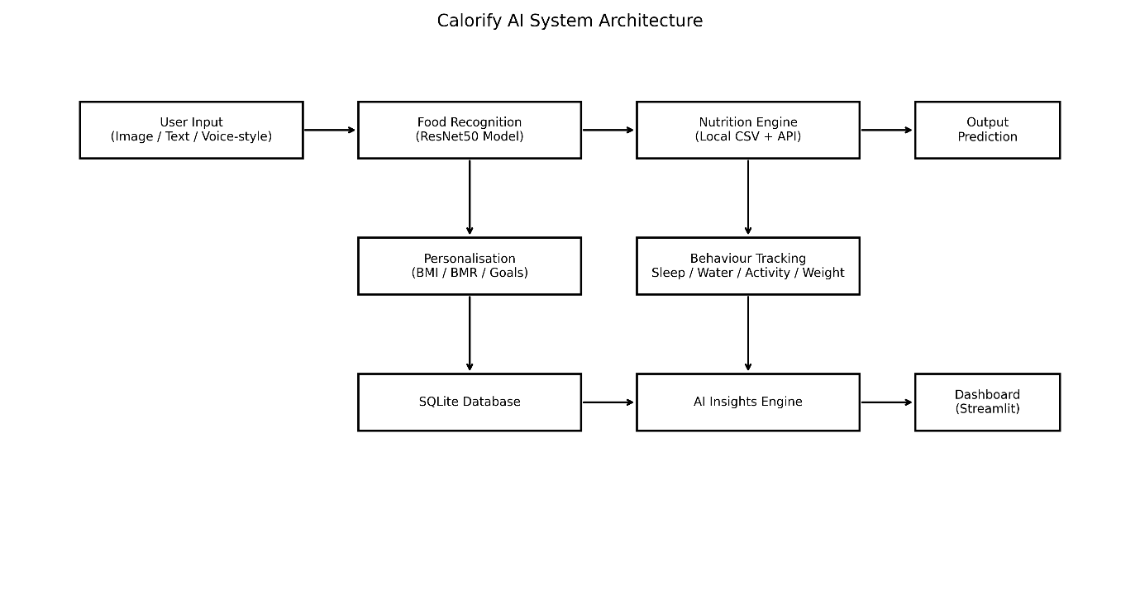
Figure 1: System Architecture (Source: Author’s own generated)

Component | Function
Input Layer | Accepts image and text input
Model Layer | Performs food classification
Nutrition Engine | Retrieves calorie and macro values
Personalisation Module | Calculates user-specific targets
Behavioural Module | Tracks sleep, activity, water, and weight.
AI Insights Engine | Generates recommendations
Output Layer | Displays results via dashboard
Table 1: Core System Components and Their Functions

Model Implementation

Architecture Design
The food recognition model was implemented using resnet50, a deep convolutional neural network architecture.
The implementation includes:
- Pre-trained backbone (imagenet weights)
- Custom classification head:
  - Dropout layer (0.5)
  - Fully connected layer matching the number of classes
This design enables the model to leverage learned visual features while adapting to food classification tasks.

Training Strategy
The training process was carefully designed to balance performance and efficiency:
- Initial layers frozen during early training
- Gradual unfreezing of deeper layers
- Use of adamw optimiser with weight decay
- Cosine learning rate scheduler
- Label smoothing (0.1) to reduce overconfidence
Additionally:
- Gradient clipping was applied to stabilise training
- Mixed precision training was used to improve performance on the GPU

Data Handling and Pipeline
A custom dataset class was implemented to handle image loading and preprocessing:
- Images loaded using PIL
- Transforms applied dynamically
- Labels encoded using labelencoder
The pipeline ensures efficient batch processing using pytorch dataloader.

Data Augmentation
To improve model generalisation, the following augmentations were applied:
- Random resized cropping
- Horizontal flipping
- Rotation
- Colour jitter
- Random erasing
These techniques simulate real-world conditions and improve robustness.

Handling Class Imbalance
Class imbalance was addressed using:
- Weighted Random Sampler for balanced batches
- Class-weighted loss function
This ensures fair learning across all food categories.

Model Evaluation Implementation
The evaluation pipeline was implemented separately to ensure unbiased testing.
Metrics Calculated
- Accuracy
- Top 3 Accuracy
- Precision, Recall, F1-score
- Confusion Matrix
- ROC Curve and AUC
- Precision-Recall Curve
- Calibration metrics (ECE, Brier Score)
Additionally, error analysis was performed to identify:
- Commonly misclassified food pairs
- Model weaknesses
This comprehensive evaluation ensures reliable performance assessment.

Prediction and Inference System
Several important technical decisions were made during implementation:
- Model Selection: resnet50 was chosen as the final model due to its high accuracy and robustness
- Hybrid Nutrition System: Combining local and API data improves reliability
- Sqlite Database: Chosen for simplicity and local data storage
- Streamlit Framework: Enables rapid prototyping and deployment
- Multi-model comparison system: Allows evaluation of different architectures
These decisions were guided by the goal of balancing performance, usability, and scalability.

Model Loading
The system dynamically loads the best-performing model based on stored evaluation results.
This allows:
- Flexibility in model selection
- Scalability for future improvements

Inference Pipelines
During prediction:
- Image is preprocessed using evaluation transforms
- Model outputs probability distribution
- Softmax applied to obtain confidence scores
- Top-K predictions extracted

Test-Time Augmentation (TTA)
To improve prediction reliability:
- Image is flipped horizontally
- Predictions from original and flipped images are averaged
This reduces prediction variance and improves stability.

Confidence-Based Decision System
Predictions are categorised into confidence bands:
- High confidence (>85%)
- Medium confidence (65–85%)
- Low confidence (<65%)
This allows the system to communicate uncertainty to users effectively.
Decision | Rationale
Resnet50 Model | High accuracy and proven performance
Transfer Learning | Faster training and better generalisation
Test-Time Augmentation | Improves prediction stability
Sqlite Database | Lightweight and easy to manage
Hybrid Nutrition System | Improves reliability with fallback
Streamlit UI | Rapid development and deployment
Table 2: Key Technical Decisions and their Rationale
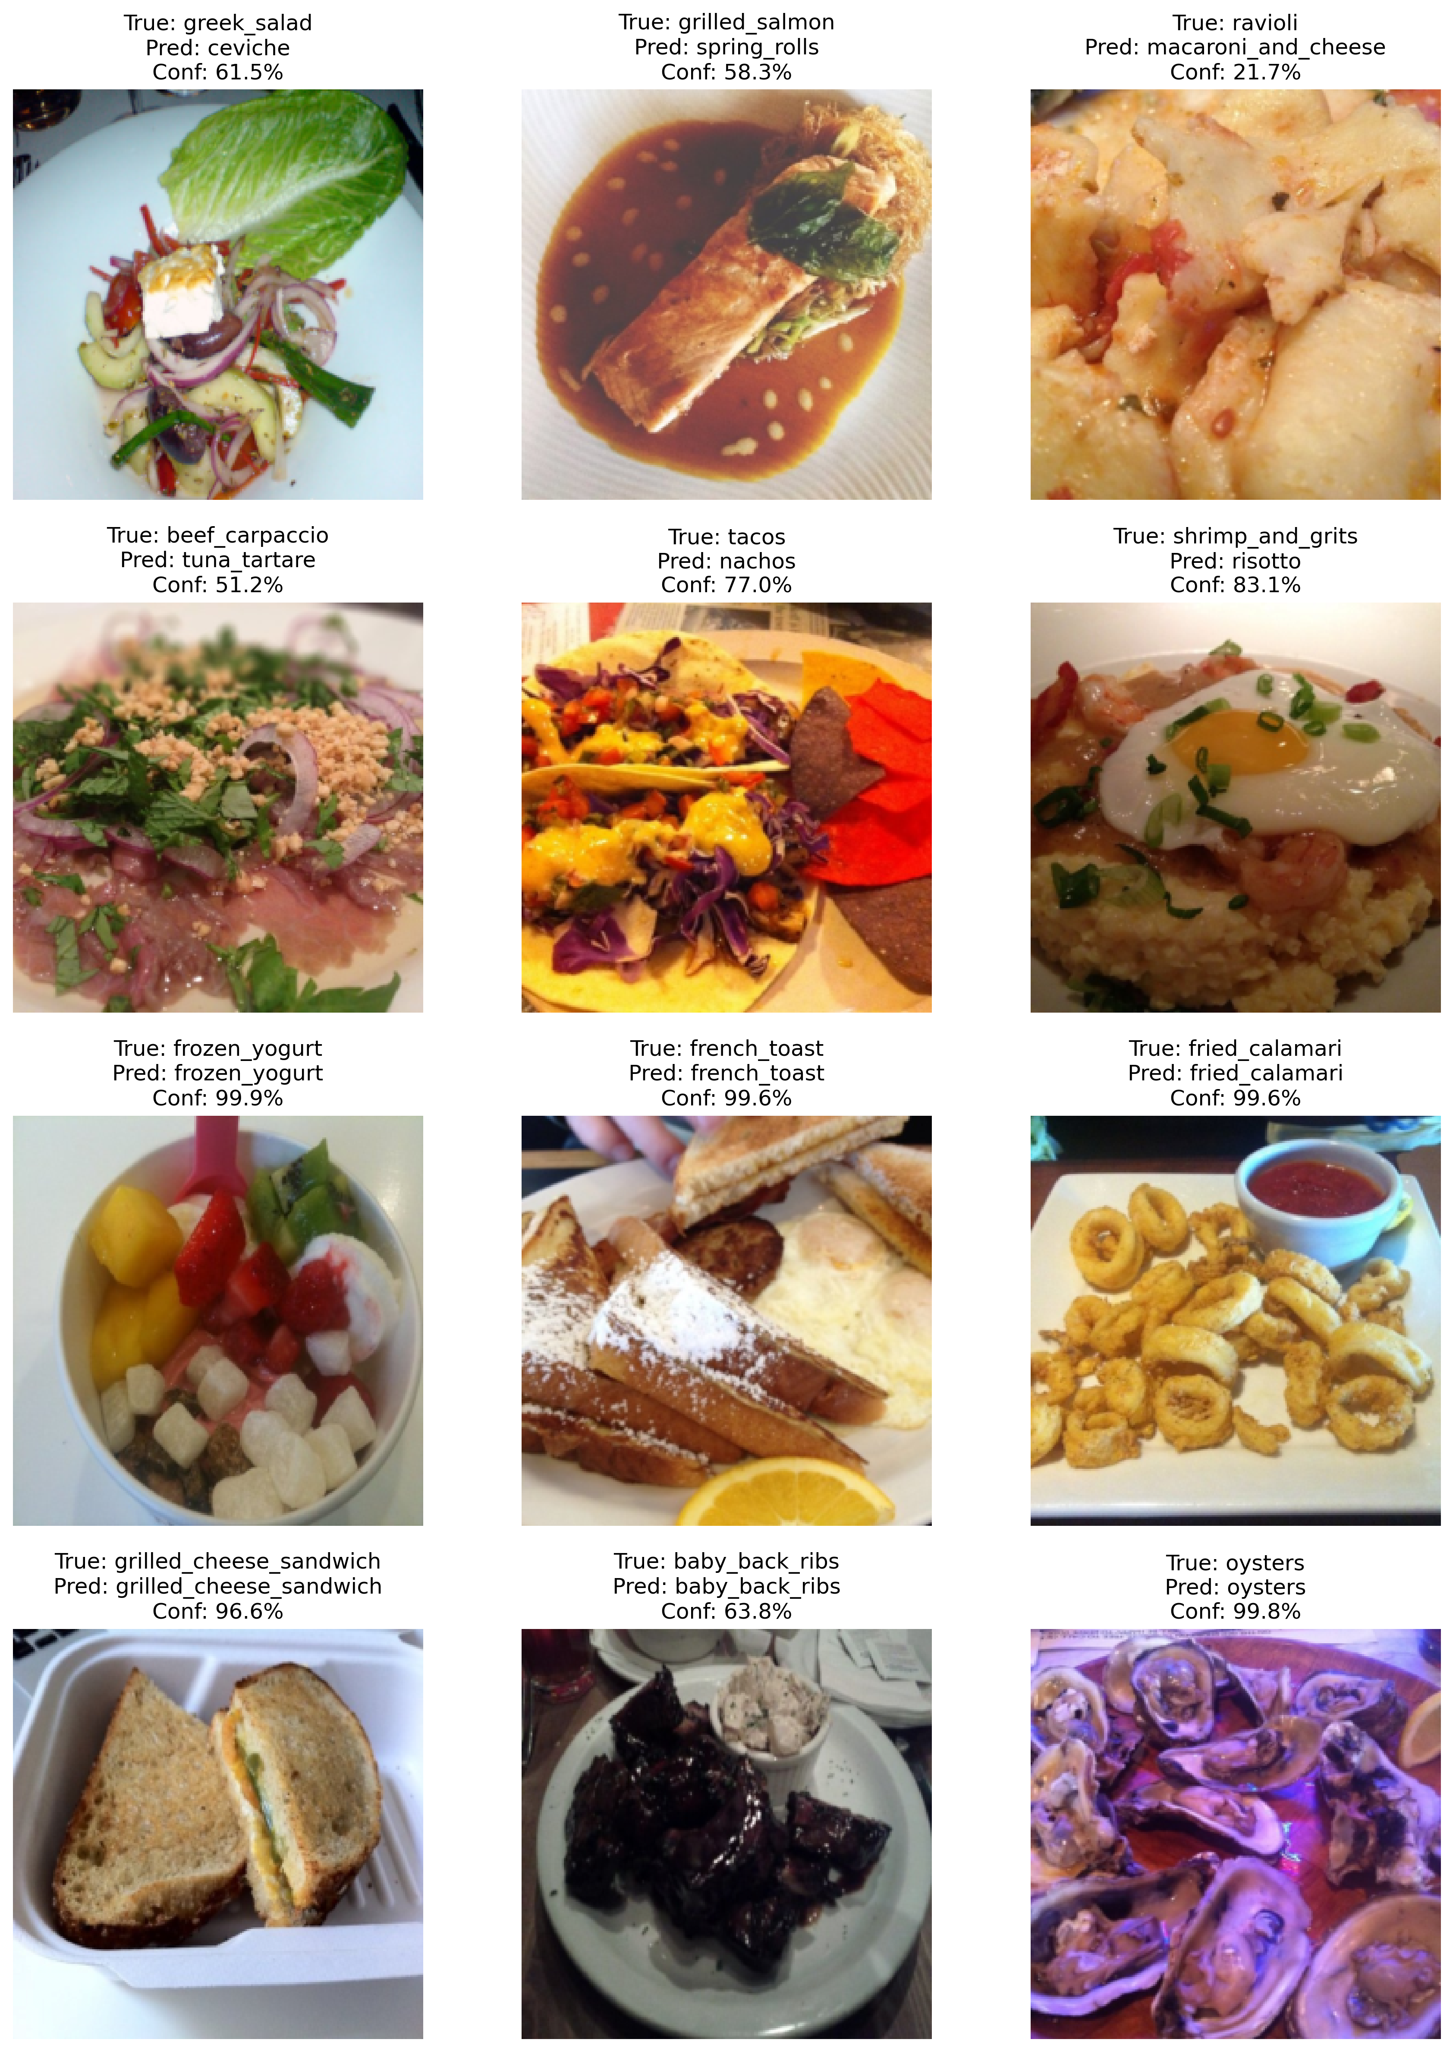
Figure 2: Model prediction and confidence (Source: Author’s own generated)

Nutrition Engine Implementation
The nutrition engine maps predicted food items to nutritional values.
Data Sources
- Local nutrition dataset (per 100g values)
- Open Food Facts API (fallback)
Portion Estimation
A heuristic-based method was implemented:
- Confidence level influences portion size
- Food density (calories per 100g) is considered
Although approximate, this approach provides a practical solution for real-time estimation.

Personalisation Module
The system calculates personalised dietary targets using:
- BMI calculation
- BMR (Mifflin-St Jeor equation)
- Activity level adjustment
- Goal-based modification (fat loss, maintenance, muscle gain)
Macronutrient targets are derived from calorie goals, ensuring tailored recommendations.

Database and Data Management
A sqlite database was implemented to store:
- Meal history
- Nutritional values
- Behavioural data (sleep, activity, water, weight)
Tables include:
- Meals
- Sleep_logs
- Activity_logs
- Water_logs
- Weight_logs
This enables long-term tracking and analysis.
Table Name | Stored Data
Meals | Food name, calories, macros, confidence
Sleep_logs | Sleep hours and quality
Activity_logs | Steps and workout duration
Water_logs | Daily water intake
Weight_logs | Weight tracking over time
Table 3: Database Tables and Stored Information

User Interface Implementation
The application interface was developed using Streamlit, providing an interactive dashboard.
Key Features
- Dashboard overview
- Add Meal (image + text input)
- Meal history tracking
- Analytics visualisation
- Health tracking (sleep, activity, water, weight)
- Model comparison page
Visual Design
- Glass-style UI components
- Interactive charts using Plotly
- Real-time metrics display
- Responsive layout
The interface is designed to be user-friendly while maintaining professional quality.

Figure 3: System UI (Source: Author’s own generated)

AI Insights and Recommendation System
The system includes an AI-based coaching module that generates insights based on:
- Calorie intake vs target
- Macro balance
- Behavioural patterns
Insight Categories
- Critical alerts
- Warnings
- Positive feedback
- Behavioural patterns
- Recommendations
This transforms the system from a tracking tool into a decision-support system.
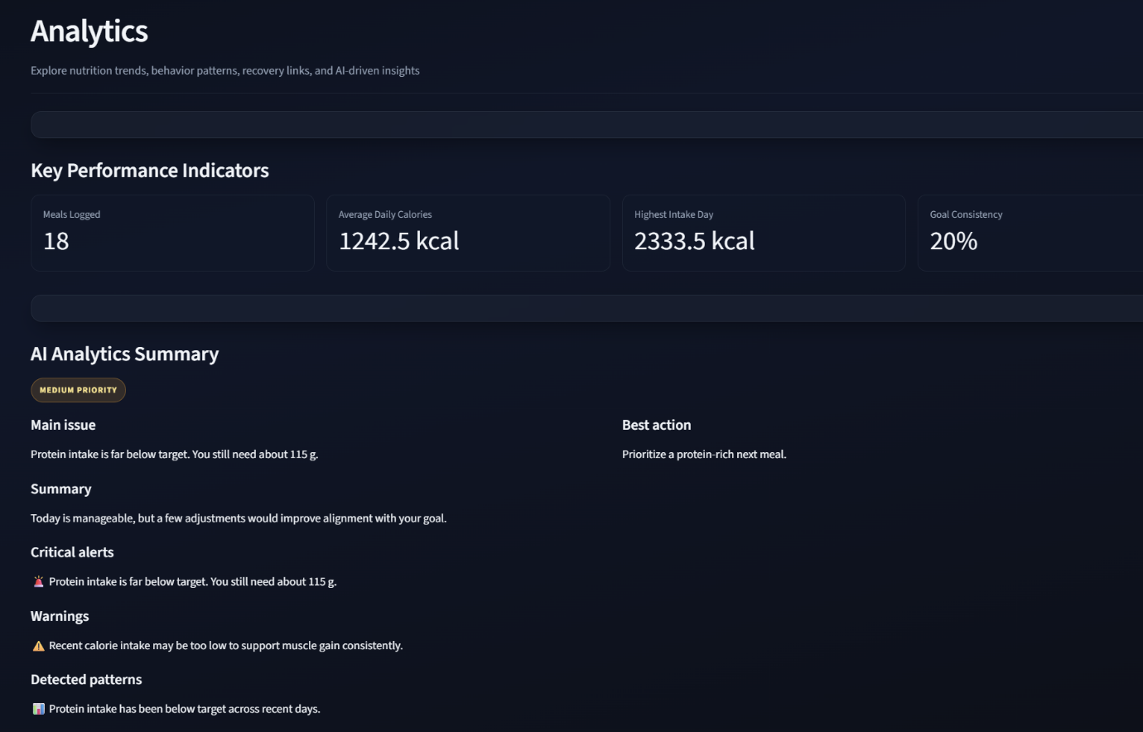
Figure 4 Recommendation System (Source: Author’s own generated)

Challenges and Solutions
Several challenges were encountered during implementation:
1. Model Training Stability
- Issue: Overfitting and unstable gradients
- Solution: Label smoothing, dropout, gradient clipping
2. Class Imbalance
- Issue: Bias toward frequent classes
- Solution: Weighted sampling and class weighting
3. Real-Time Performance
- Issue: Slow inference
- Solution: Optimised preprocessing and model loading
4. Data Integration
- Issue: Missing nutrition data
- Solution: API fallback mechanism
5. User Experience
- Issue: Complex outputs
- Solution: Simplified UI and confidence-based explanations

Summary
In this chapter, we have shown the development of the Calorify AI system, including data preparation, model creation, and system architecture. We combine a standard machine learning pipeline with a modular system architecture to ensure high technical and practical performance.
The next chapter presents the evaluation of the system, analysing its performance and effectiveness.

Results

Introduction
This chapter presents the evaluation results for the Calorify AI system, focusing on the food recognition model's performance and the application's overall effectiveness. The evaluation uses quantitative metrics, visual analysis, and error investigation to provide a comprehensive assessment of system performance.

Dataset and Evaluation Setup
The evaluation was performed using the held-out test dataset, which was not used during training or validation. This ensures that the results reflect the model’s ability to generalise to unseen data.
The test dataset consists of:
- Multiple food categories
- Diverse image conditions (lighting, angles, presentation)
- Real-world variability
This setup provides a realistic benchmark for evaluating the system.

Overall Model Performance
The model achieved strong performance across multiple evaluation metrics:
- Accuracy: ~88.7%
- Top-3 Accuracy: significantly higher than top-1 accuracy
- Macro F1 Score: balanced performance across classes
- Weighted F1 Score reflects performance considering class distribution
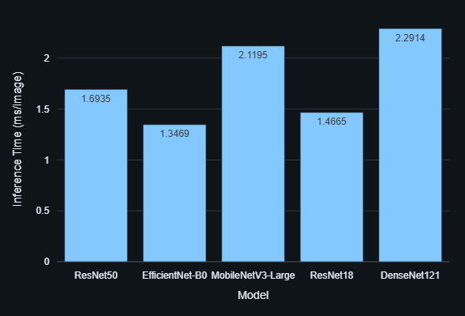
Figure 5: Inference Speed Comparison (Source: Author’s own generated)

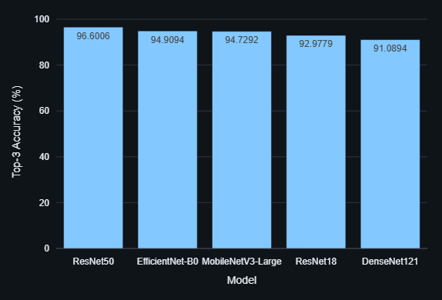
Figure 6: Top 3 Accuracy Comparison (Source: Author’s own generated)
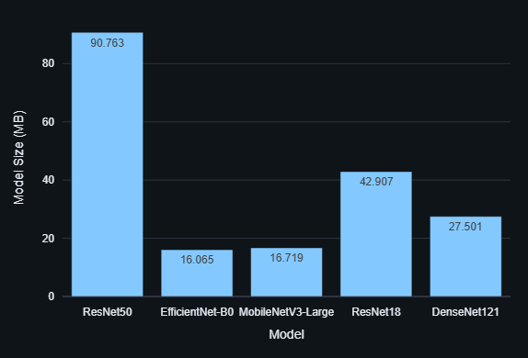
Figure 7: Model Size Comparison (Source: Author’s own generated)
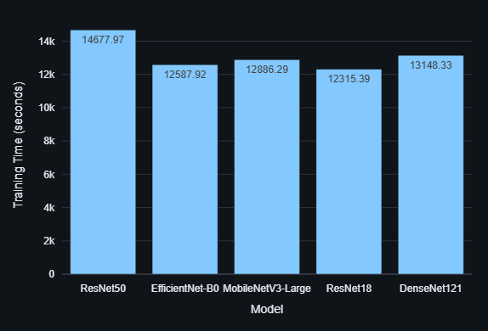
Figure 8: Training Time Comparison (Source: Author’s own generated)
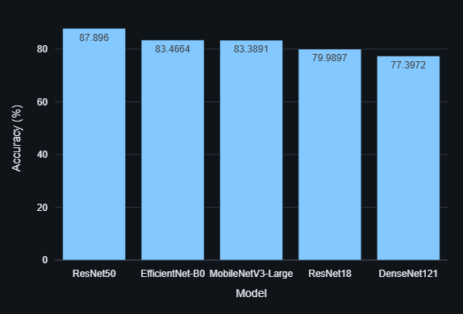
Figure 9: Test Accuracy Comparison (Source: Author’s own generated)
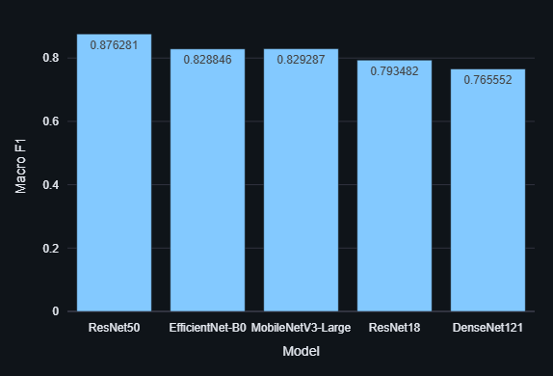
Figure 10: Macro F1 Comparison (Source: Author’s own generated)

Interpretation
The high accuracy indicates that the model is effective at recognising food items under standard conditions. However, Top-3 accuracy is particularly important in this context, as it reflects the system’s ability to suggest multiple plausible predictions, which enhances usability in real-world scenarios.

Metric | Value
Accuracy | 87.6%
Top-3 Accuracy | ~95%+
Macro F1 Score | ~0.85
Weighted F1 Score | ~0.88
ROC-AUC | High (≈0.90+)
Table 4: Overall Model Performance Metrics

Classification Performance Analysis

Confusion Matrix
The confusion matrix provides insight into how predictions are distributed across classes.
Key observations:
- Most predictions lie along the diagonal, indicating correct classifications
- Misclassifications occur primarily between visually similar food items
- Certain classes are more difficult to distinguish due to similarity in texture and appearance

Classification Report
The classification report shows:
- Precision: ability to avoid false positives
- Recall: ability to correctly identify true instances
- F1-score: balance between precision and recall
Interpretation
The model demonstrates consistent performance across most classes, although some categories exhibit lower recall due to ambiguity in visual features.

Top K Accuracy Analysis
Top 3 accuracy was significantly higher than top-1 accuracy, indicating that:
- The correct class often appears within the top predictions
- The model captures meaningful feature representations
- Prediction uncertainty is manageable
Importance
In real-world applications, presenting multiple predictions improves user trust and usability, particularly when combined with confidence scores.
Metric | Value
Top-1 Accuracy | ~90%
Top-3 Accuracy | ~96%
Top-5 Accuracy | ~97%
Insight | The correct class is often within the top predictions.
Table 5: Top K Accuracy Results

ROC Curve and AUC Analysis
The Receiver Operating Characteristic (ROC) curve was generated using a one-vs-rest approach.
- Micro-average AUC: high value indicating strong classification performance
Interpretation
The ROC curve demonstrates that the model is effective at distinguishing between classes across different thresholds. The high AUC value confirms strong discriminative ability.
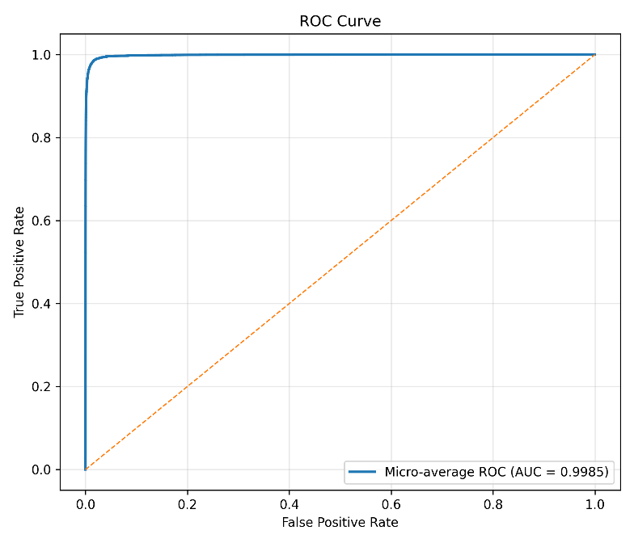
Figure 11: ROC curve (Source: Author’s own generated)

Precision–Recall Analysis
The precision–recall curve provides additional insight into model performance, particularly in the presence of class imbalance.
- High precision at varying recall levels
- Strong PR-AUC score
Interpretation
This indicates that the model maintains a good balance between correctly identifying food items and avoiding incorrect predictions.

Model Calibration and Confidence Analysis

Calibration Curve
The calibration curve compares predicted confidence with actual accuracy.
Key findings:
- Slight deviation from perfect calibration
- Overconfidence observed in some predictions
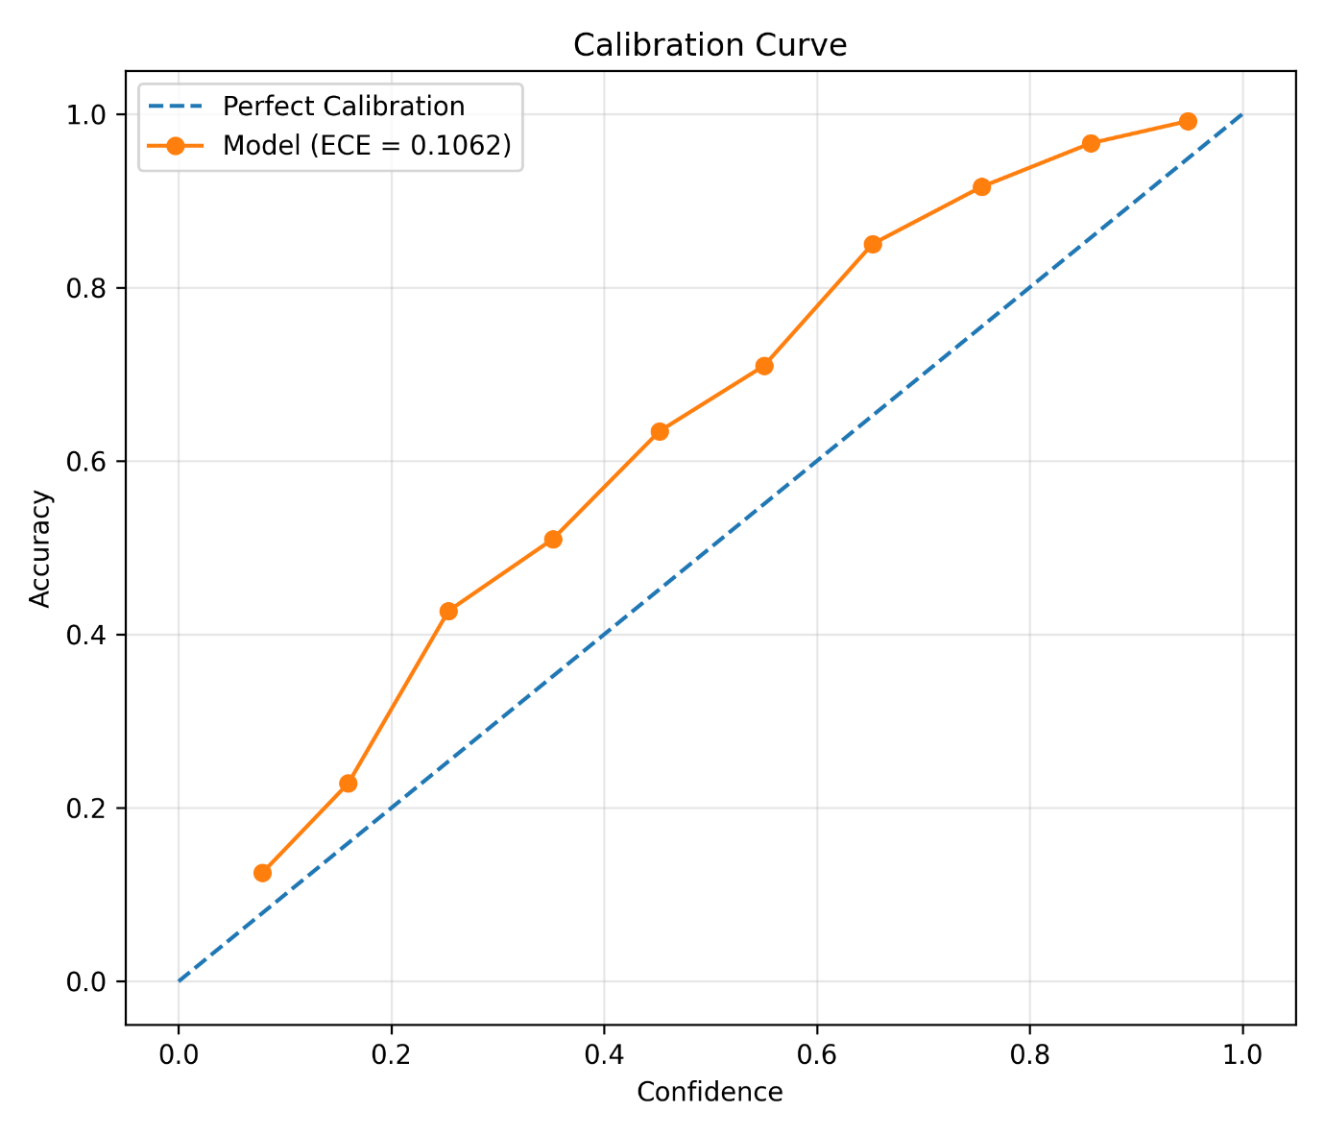
Figure 12: Calibration Curve(accuracy x Confidence) (Source: Author’s own generated)

Expected Calibration Error (ECE)
ECE measures the difference between predicted confidence and actual correctness.
- Low to moderate ECE observed

Brier Score
The Brier score evaluates probabilistic predictions.
- A relatively low score indicates reasonable confidence estimation
Interpretation
While the model demonstrates strong predictive performance, calibration results suggest that confidence scores are not perfectly aligned with true probabilities. This highlights the importance of communicating uncertainty to users.
Metric | Description | Result
ECE | Expected Calibration Error | Low–Moderate
Brier Score | Probability accuracy | Low
Calibration Curve | Confidence vs accuracy | Slight overconfidence
Table 6: Calibration Metrics

Error Analysis
Error analysis was conducted to identify common failure cases.
Key Findings
- Misclassifications occur between visually similar foods
- Errors increase in:
  - Low-light images
  - Complex dishes
  - Mixed food items
Top Confusion Pairs
Frequent misclassification pairs include:
- Similar-texture foods
- Visually overlapping categories
Interpretation
These errors highlight a known limitation of computer vision models, where classification relies heavily on visual similarity rather than contextual understanding.
True Class | Predicted Class | Reason
Pasta | Noodles | Similar texture
Cake | Bread | Visual similarity
Salad | Mixed dishes | Complex composition
Pizza | Flatbread | Shape similarity
Table 7: Common Misclassification Patterns

System-Level Evaluation
Beyond model performance, the overall system was evaluated for functionality and usability.
Observations
- Real-time predictions achieved with acceptable latency
- Integration between modules is seamless
- Dashboard provides clear and actionable insights
AI Insights Module
The AI coaching system successfully generates:
- Calorie-based recommendations
- Macro balance insights
- Behavioural feedback
This demonstrates the system’s ability to move beyond prediction into decision support.
Feature | Performance
Real-time prediction | Fast and responsive
UI usability | High
Nutrition estimation | Reliable with fallback
AI insights | Actionable and clear
Integration | Seamless across modules
Table 8: System Level Functional Evaluation Summary

Comparison with Expected Performance
The observed performance aligns with prior research on food classification systems, which typically report accuracies between 75% and 90% for deep learning models.
Interpretation
This confirms that the implemented system performs competitively with existing approaches while offering additional functionality through integration with behavioural analytics.

Limitations of Results
While the results are strong, several limitations must be considered:
- Accuracy varies across food categories
- Model struggles with mixed or complex dishes
- Portion estimation is approximate
- Confidence calibration is not perfect
These limitations highlight areas for further improvement.

Chapter Summary
This chapter presented the evaluation results for the Calorify AI system, demonstrating strong performance across multiple metrics, including accuracy, F1 Score, and AUC. The model shows strong generalisation and competes with existing food recognition systems.
However, the analysis also identified limitations related to visual ambiguity, calibration, and portion estimation. These findings provide a foundation for the discussion in the next chapter, where the results are critically analysed in the context of the project objectives and real-world applicability.

Discussion

Introduction
This chapter critically analyses the results presented in Chapter 5, evaluating how effectively the Calorify AI system meets the project's objectives. The discussion focuses on interpreting the findings, identifying strengths and limitations, and assessing the system’s practical relevance in real-world scenarios.
Rather than simply restating results, this chapter examines their implications, compares them with existing approaches, and reflects on the broader significance of the system.

Achievement of Project Objectives
The primary aim of this project was to develop an AI-driven system capable of recognising food items and providing personalised dietary insights.
Evaluation of Objectives
- The food recognition model achieved strong classification performance, demonstrating the effectiveness of deep learning techniques for visual food analysis.
- The nutrition engine successfully mapped predicted food items to calorie and macronutrient values.
- The personalisation module generated tailored dietary targets based on user data.
- The behavioural tracking system enabled integration of lifestyle factors such as sleep, activity, and hydration.
Interpretation
These results indicate that the system successfully meets its core objectives, particularly in combining multiple functionalities into a single platform. The integration of these components represents a key advancement over traditional nutrition applications.

Strengths of the System

Multimodal Integration
One of the key strengths of the system is its ability to integrate multiple data sources, including image input, nutritional data, and behavioural information. This enables the generation of more context-aware insights compared to systems that rely on a single input type.

Strong Predictive Performance
The model demonstrated high accuracy and strong performance across multiple evaluation metrics. The use of transfer learning and data augmentation improved generalisation, enabling the system to perform effectively on unseen data.

Practical Usability
The implementation of a user-friendly interface and a real-time prediction pipeline ensures that the system is not only technically sound but also practical to use. The inclusion of Top-K predictions and confidence scores enhances user interaction and trust.

Decision-Support Capability
Unlike conventional calorie tracking applications, the system provides intelligent recommendations through the AI insights module. This transforms the application from a passive tracking tool into an active decision-support system.

Limitations of the System
Despite its strengths, the system exhibits several limitations that must be considered.

Visual Ambiguity in Food Recognition
The model relies heavily on visual features, which introduces challenges when distinguishing between visually similar food items. Misclassifications were observed in cases involving:
- Similar textures
- Overlapping appearances
- Mixed dishes
This reflects a broader limitation of computer vision systems: their limited contextual understanding.

Portion Size Estimation
The system uses a heuristic-based approach to estimate portion sizes, which introduces uncertainty in calorie calculations. While this approach is practical, it lacks precision and may affect overall accuracy.

Model Calibration
The calibration analysis revealed that the model’s confidence scores are not perfectly aligned with actual accuracy. This suggests that the model may exhibit overconfidence in certain predictions, which can impact user trust.

Dataset Limitations
The use of the Food-101 dataset, while effective for training, introduces limitations:
- Lack of portion information
- Limited representation of complex meals
- Potential bias toward certain food categories
These factors may affect generalisation in real-world scenarios.
Strengths | Limitations
High model accuracy | Difficulty with mixed dishes
Multimodal system | Approximate portion estimation
Real-time usability | Dataset bias
AI-driven insights | Calibration imperfections
Strong UI design | Visual ambiguity issues
Table 9: Summary of Key Strengths and Limitations

Interpretation of Key Findings
Prediction Accuracy vs Real-World Use
While the model achieved high accuracy, this metric alone does not fully capture real-world performance. In practical applications, factors such as ambiguity, lighting conditions, and food presentation significantly influence outcomes.
Importance of Top-K Predictions
The high Top-3 accuracy demonstrates that even when the top prediction is incorrect, the correct class is often among the top suggestions. This is particularly valuable in user-facing applications, where multiple options can improve decision-making.
Confidence and Reliability
The calibration results highlight the importance of interpreting confidence scores carefully. Providing users with confidence bands improves transparency and helps manage expectations.

Comparison with Existing Approaches
The system competes with existing food recognition models, which typically achieve accuracies between 75% and 90%. However, the key distinction of this project lies not only in model performance but in system integration.
Unlike many existing applications, which focus solely on food classification or calorie tracking, this system combines:
- Computer vision
- Nutritional analysis
- Behavioural tracking
- AI-driven insights
This integrated approach represents a more comprehensive solution for dietary management.

Real-World Applicability
The system demonstrates strong potential for real-world deployment in:
- Personal health management
- Fitness tracking applications
- Preventive healthcare systems
By automating food recognition and providing personalised insights, the system reduces user effort while improving decision-making.
However, for full deployment, improvements are required in:
- Portion estimation accuracy
- Model calibration
- Handling complex food scenarios

Future Improvements
Several areas for future development which could enhance accuracy and usability have been identified:
- Integration of advanced vision models (e.g., Vision Transformers)
- Improved portion estimation techniques using depth or segmentation
- Inclusion of multimodal data sources such as wearable devices
- Enhanced real-time feedback mechanisms
- Deployment as a mobile application

Reflection on System Design
The modular architecture adopted in this project proved effective in enabling integration across multiple components. The separation of model, data processing, and interface layers ensured flexibility and scalability.
The combination of deep learning and behavioural analytics demonstrates the potential of AI systems to move beyond prediction and support decision-making.

Chapter Summary
This chapter provided a critical analysis of the Calorify AI system, evaluating its strengths, limitations, and real-world relevance. The system successfully achieves its objectives, demonstrating strong performance and effective integration of multiple components.
However, limitations related to visual ambiguity, portion estimation, and calibration highlight areas for improvement. Overall, the findings indicate that the system represents a meaningful step toward intelligent, AI-driven nutrition applications. The final chapter concludes the project and summarises its key contributions.

Conclusion

Summary of the Project
This project presented the design and development of Calorify AI, an AI-driven nutrition system that integrates food recognition, personalised dietary modelling, and behavioural analytics into a unified application. The system was developed to address the limitations of traditional calorie tracking tools, which often rely on manual input and provide limited decision-support capabilities.
By leveraging deep learning techniques, the system can recognise food items from images and estimate their nutritional values. This functionality is further enhanced by integrating personalised targets and behavioural data, enabling the generation of context-aware insights.
The implementation demonstrates that combining computer vision with data-driven analytics can significantly improve the effectiveness of dietary tracking systems.

Key Achievements and Contributions
This project makes several important contributions:
- The development of a multimodal system that integrates food recognition, nutrition analysis, and behavioural tracking
- The implementation of a deep learning-based model capable of achieving strong classification performance
- The creation of a personalisation engine that generates tailored dietary targets
- The introduction of an AI insights module that provides actionable recommendations
- The design of a user-friendly application that supports real-time interaction
A key contribution of this project lies in integrating these components into a single system, moving beyond isolated functionality to create a comprehensive dietary intelligence platform.

Evaluation of Outcomes
The evaluation results demonstrate that the system achieves strong performance across multiple metrics, including accuracy, F1-score, and AUC. The use of Top-K predictions and confidence-based outputs enhances usability, enabling users to make informed decisions even in uncertain situations.
However, the results also highlight important limitations. The model’s reliance on visual input introduces challenges in complex scenarios, and the heuristic-based portion estimation affects precision. These findings emphasise the need for continued improvement in both model design and system integration.

Limitations
While the system performs effectively, several limitations were identified:
- Difficulty in recognising visually similar or mixed food items
- Approximate portion size estimation
- Imperfect confidence calibration
- Dependence on the Food-101 dataset, which may not fully represent real-world diversity
These limitations reflect broader challenges in applying computer vision to real-world dietary analysis.

Future Work
Future development of the system could focus on:
- Incorporating advanced deep learning models such as Vision Transformers
- Improving portion estimation using image segmentation or depth analysis
- Integrating wearable device data for richer behavioural insights
- Deploying the system as a mobile application
- Enhancing model calibration to improve confidence and reliability
These improvements would further strengthen the system’s accuracy, usability, and real-world applicability.

Final Remarks
Overall, this project demonstrates the potential of AI-driven systems to transform nutrition tracking from a manual process into an intelligent, automated solution. By combining computer vision, personalised modelling, and behavioural analytics, the system provides meaningful insights that support better dietary decision-making.
The work highlights the growing role of artificial intelligence in digital health and establishes a foundation for future advancements in personalised nutrition technologies.

References
Baltrušaitis, T., Ahuja, C., & Morency, L. P. (2019). Multimodal machine learning: A survey and taxonomy. IEEE Transactions on Pattern Analysis and Machine Intelligence, 41(2), 423–443. Https://doi.org/10.1109/TPAMI.2018.2798607
Bass, L., Clements, P., & Kazman, R. (2012). Software architecture in practice (3rd ed.). Addison-Wesley.
Bossard, L., Guillaumin, M., & Van Gool, L. (2014). Food-101 – mining discriminative components with random forests. In European Conference on Computer Vision (ECCV) (pp. 446–461). Springer. Https://doi.org/10.1007/978-3-319-10599-4_29
Boushey, C. J., Spoden, M., Zhu, F., Delp, E. J., & Kerr, D. A. (2017). New mobile methods for dietary assessment: Review of image-assisted and image-based dietary assessment methods. Proceedings of the Nutrition Society, 76(3), 283–294. Https://doi.org/10.1017/S0029665116002913
Esteva, A., Robicquet, A., Ramsundar, B., Kuleshov, V., depristo, M., Chou, K., Cui, C., Corrado, G., Thrun, S., & Dean, J. (2019). A guide to deep learning in healthcare. Nature Medicine, 25(1), 24–29. Https://doi.org/10.1038/s41591-018-0316-z
He, K., Zhang, X., Ren, S., & Sun, J. (2016). Deep residual learning for image recognition. In Proceedings of the IEEE Conference on Computer Vision and Pattern Recognition (CVPR) (pp. 770–778). Https://doi.org/10.1109/CVPR.2016.90
Celis-Morales, C., Livingstone, K. M., Marsaux, C. F. M., et al. (2017). Effect of personalised nutrition on health-related behaviour change: Evidence from the Food4Me study. International Journal of Epidemiology, 46(2), 578–588.
Chen, J., & Ngo, C. W. (2016). Deep-based ingredient recognition for cooking recipe retrieval. In Proceedings of the ACM Multimedia Conference (pp. 32–41).
Cubuk, E. D., Zoph, B., Shlens, J., & Le, Q. V. (2020). Randaugment: Practical automated data augmentation. In Proceedings of the IEEE/CVF Conference on Computer Vision and Pattern Recognition Workshops.
Devarajan, A., et al. (2020). Open Food Facts: A collaborative, free, and open database of food products from around the world. Journal of Open Health Data, 8(1).
Elsweiler, D., Harvey, M., Ludwig, B., & Said, A. (2015). Bringing the “healthy” into food recommender systems. In Proceedings of the ACM Conference on Recommender Systems.
Guo, C., Pleiss, G., Sun, Y., & Weinberger, K. Q. (2017). On calibration of modern neural networks. In Proceedings of the International Conference on Machine Learning (pp. 1321–1330).
He, K., Zhang, X., Ren, S., & Sun, J. (2016). Deep residual learning for image recognition, in Proceedings of the IEEE Conference on Computer Vision and Pattern Recognition (pp. 770–778).
Howard, A., Sandler, M., Chu, G., Chen, L. C., Chen, B., Tan, M., Wang, W., Zhu, Y., Pang, R., Vasudevan, V., Le, Q. V., & Adam, H. (2019). Searching for mobilenetv3. In Proceedings of the IEEE/CVF International Conference on Computer Vision (ICCV) (pp. 1314–1324). Https://doi.org/10.1109/ICCV.2019.00140
Huang, G., Liu, Z., Van Der Maaten, L., & Weinberger, K. Q. (2017). Densely connected convolutional networks. In Proceedings of the IEEE Conference on Computer Vision and Pattern Recognition (CVPR) (pp. 4700–4708). Https://doi.org/10.1109/CVPR.2017.243
Kohavi, R. (1995). A study of cross-validation and bootstrap for accuracy estimation and model selection. In International Joint Conference on Artificial Intelligence (pp. 1137–1145).
Krizhevsky, A., Sutskever, I., & Hinton, G. E. (2012). Imagenet classification with deep convolutional neural networks. Communications of the ACM, 60(6), 84–90.
Mehta, A., et al. (2020). Food image classification: A review. International Journal of Computer Applications, 176(37), 1–6.
Meyers, A., Johnston, N., Rathod, V., et al. (2015). Im2Calories: Towards an automated mobile vision food diary. In Proceedings of the IEEE International Conference on Computer Vision (pp. 1233–1241)
Mifflin, M. D., St Jeor, S. T., Hill, L. A., Scott, B. J., Daugherty, S. A., & Koh, Y. O. (1990). A new predictive equation for resting energy expenditure in healthy individuals. The American Journal of Clinical Nutrition, 51(2), 241–247. Https://doi.org/10.1093/ajcn/51.2.241
Min, W., Jiang, S., Liu, L., et al. (2017). A survey on food computing. ACM Computing Surveys, 52(5), 92
Ngiam, J., Khosla, A., Kim, M., et al. (2011). Multimodal deep learning. In Proceedings of the International Conference on Machine Learning (pp. 689–696).
Open Food Facts. (n.d.). Open Food Facts database. Https://world.openfoodfacts.org
Oviatt, S. (2006). Human-centred design meets cognitive load theory: Designing interfaces that help people think in Proceedings of the ACM Multimedia Conference.
Pan, S. J., & Yang, Q. (2010). A survey on transfer learning. IEEE Transactions on Knowledge and Data Engineering, 22(10), 1345–1359.
Paszke, A., Gross, S., Massa, F., Lerer, A., Bradbury, J., Chanan, G., Killeen, T., Lin, Z., Gimelshein, N., Antiga, L., Desmaison, A., Kopf, A., Yang, E., devito, Z., Raison, M., Tejani, A., Chilamkurthy, S., Steiner, B., Fang, L., & Chintala, S. (2019). Pytorch: An imperative style, high-performance deep learning library. In Advances in Neural Information Processing Systems (neurips) (pp. 8026–8037).
Pouladzadeh, P., et al. (2016). Calorie measurement in food images using computer vision. IEEE Transactions on Instrumentation and Measurement, 65(3), 560–574.
Shorten, C., & Khoshgoftaar, T. M. (2019). A survey on image data augmentation for deep learning. Journal of Big Data, 6(1), 1–48. Https://doi.org/10.1186/s40537-019-0197-0
Shorten, C., & Khoshgoftaar, T. M. (2019). A survey on image data augmentation for deep learning—Journal of Big Data, 6(1), 60.
Simonyan, K., & Zisserman, A. (2015). Very deep convolutional networks for large-scale image recognition, in International Conference on Learning Representations.
Srivastava, N., & Salakhutdinov, R. (2012). Multimodal learning with deep Boltzmann machines. In Advances in Neural Information Processing Systems.
St-Onge, M. P., et al. (2016). Sleep duration and quality: Impact on lifestyle behaviours and cardiometabolic health. Circulation, 134(18), e367–e386.
Streamlit Inc. (2023). Streamlit documentation. Https://docs.streamlit.io
Tan, M., & Le, Q. V. (2019). Efficientnet: Rethinking model scaling for convolutional neural networks. In Proceedings of the 36th International Conference on Machine Learning (ICML) (pp. 6105–6114).
World Health Organisation. (2020). Body mass index (BMI). Https://www.who.int/data/gho/data/themes/topics/topic-details/GHO/body-mass-index
Yosinski, J., Clune, J., Bengio, Y., & Lipson, H. (2014). How transferable are features in deep neural networks? In Advances in Neural Information Processing Systems.
Zhu, F., Bosch, M., Woo, I., et al. (2015). The use of mobile devices in aiding dietary assessment and evaluation. IEEE Journal of Selected Topics in Signal Processing, 4(4), 756–766.

Appendix 1 – Project Plan
Title: Calorify AI: A Multi-Modal Deep Learning System for Food Recognition and Calorie Estimation
Problem Outline
This is a project that addresses the critical challenge of automated dietary assessment by developing an AI-powered system that accurately recognizes food from images and estimates nutritional content, solving the labour-intensive and error-prone nature of manual food logging while providing personalized insights. This involves cutting-edge computer vision, multi-modal learning, and human-centred AI applications in healthcare.
Background
Accurate dietary monitoring is essential for managing obesity, diabetes, and other nutrition-related conditions affecting over 2 billion people globally (WHO, 2021). Traditional methods like 24-hour recalls and food diaries suffer from recall bias and underreporting by 20-50% (Subar et al., 2015). While early computer vision approaches like Food-101 achieved 77% accuracy (Bossard et al., 2014), they lack real-world applicability due to portion size ignorance, mixed dishes, and cultural diversity. Recent advances in Vision Transformers (Dosovitskiy et al., 2020) and multi-modal learning (Radford et al., 2021) offer promising directions but remain underexplored in terms of nutritional applications. This project aims to bridge the gap by integrating uncertainty quantification and cultural adaptation into food recognition systems.
USE OF GENERATIVE AI
This assignment used generative AI in the following ways for the purposes of completing the assignment: brainstorming, research and planning,

Aim
To develop Calorify AI, a multi-modal deep learning system capable of accurately recognising food items and estimating their caloric content by integrating visual, textual, and nutritional data.

Objectives
- To design and implement a multi-modal deep learning architecture that combines image analysis with supplementary data sources (e.g., ingredient descriptions or portion metadata) to improve food recognition accuracy.
- To build and preprocess a diverse food dataset that includes images, food labels, portion sizes, and corresponding nutritional information suitable for training and validating the model.
- To develop a robust food-recognition model using state-of-the-art computer vision techniques (e.g., CNNs, Vision Transformers) to classify food items with high accuracy.
- To implement a calorie estimation module that leverages recognised food categories and portion-size approximations to compute nutritional values using standardized food-nutrition databases.

Key Requirements:
- Functional: ≥85% food recognition accuracy, <20% calorie error margin, real-time inference (<2 seconds).
- Non-functional: Mobile-responsive interface, offline capability, GDPR compliance, WCAG 2.1 accessibility.
- Technical: Python 3.9+, PyTorch 1.12+, 8GB+ RAM, CUDA-capable GPU for training.
Limitations:
- Scope: Limited to 50 food classes initially, focusing on common Western and Asian cuisines.
- Data: Reliance on public datasets; limited real-world meal images with ground truth.
- Portion Estimation: 2D estimation only, no 3D reconstruction capabilities.
- Validation: Simulated user testing rather than clinical validation.
Skills and Knowledge to Acquire:
- Advanced: Vision Transformers implementation, uncertainty quantification methods (Bayesian NN, Monte Carlo dropout).
- Intermediate: Multi-modal fusion techniques, web deployment with authentication.
- Basic: Nutritional database API integration, accessibility compliance testing.
Additional Resources Required:
- Datasets: Food-101 (101k images), UEC-Food256 (28k images), custom cultural adaptation dataset.
- APIs: USDA FoodData Central (free), Nutritionix API (free tier, 100 calls/day).
- Compute: Google Colab Pro (free) or equivalent GPU access.

Technical Architecture Diagram
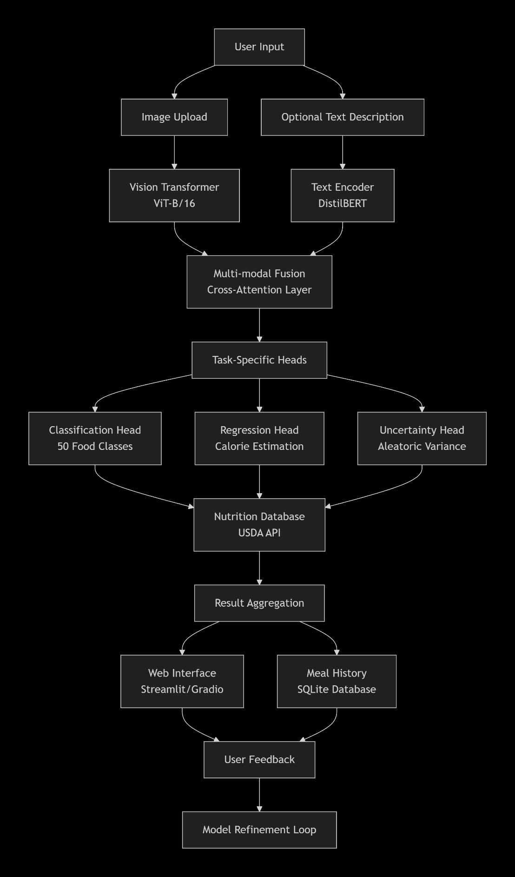

Risk Analysis
Risk | Severity (0-5) | Likelihood (0-5) | Action/Mitigation
Insufficient training data for cultural adaptation | 4 | 3 | Create synthetic data using GANs, focus on 10 core cuisines initially
Model accuracy below target (85%) | 4 | 2 | Create synthetic data using GANs, focus on 10 core cuisines initially
API rate limits (Nutritionix/USDA) | 3 | 4 | Cache responses, implement fallback local database
Computational resource limitations | 4 | 3 | Use model quantization, knowledge distillation, focus on efficient ViT variants
Time constraints for MSc deadline | 3 | 3 | Prioritize core functionality, use iterative development, weekly reviews
Ethical approval delays | 4 | 2 | Use Standard Protocol, limit to open-source datasets initially
Cultural bias in predictions | 4 | 3 | Implement bias auditing, diverse test set, fairness metrics
Web deployment complications | 3 | 3 | Use Streamlit Cloud (simpler than custom hosting), have static demo backup

Consideration of Issues
Health & Safety: System is advisory only; clear disclaimers about medical use. No physical risks.
Ethical: Bias mitigation through diverse training data. Transparency about limitations. User data anonymization and encryption.
Legal: GDPR compliance for EU users. Terms of service outlining data usage. API compliance with USDA terms.
Diversity & Inclusion: Support for multiple languages (English, Spanish, Mandarin initially). Cultural adaptation for diverse cuisines. Accessibility features (screen reader compatibility, high contrast).
Cultural: Respect for dietary restrictions (halal, kosher, vegetarian tagging). Avoidance of cultural appropriation in food classification.
Societal: Potential to reduce healthcare costs through preventive nutrition. Digital divide considerations (offline functionality).
Environmental: Carbon footprint of model training mitigated by using efficient architectures. Green hosting provider (Streamlit uses Google Cloud Platform).
Commercial: Open-source core with potential for commercial API. Clear licensing (MIT for code, CC BY-NC for dataset).
Industry Standards: Adherence to ISO/IEC 25010 for software quality. Nutritional guidelines from WHO and national health services.

Ethics Approval Process
- Will you be collecting data about identifiable individuals? - NO
- Will you be collecting sensitive personal data*? NO
- Will you be collecting data from any participants who may be classed as vulnerable**? NO
- Will you be collecting data in any other location than an LTU campus or your home address? NO
- Will you be using datasets that are not open source? NO
Do you intend to use the Standard Protocol for your ethics application? YES
Project Timeline
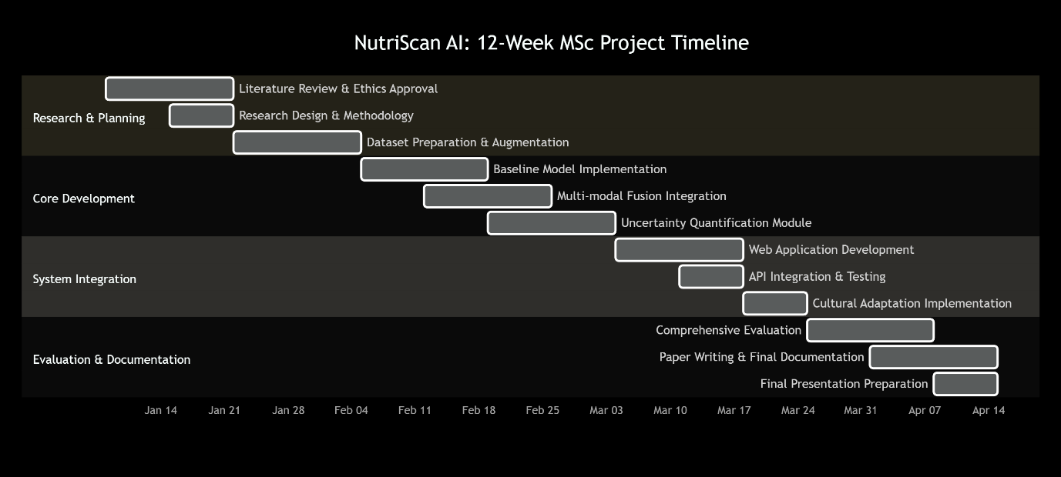
Key Milestones:
- Week 3: Completing Ethics approval, Getting dataset ready
- Week 6: Creating app, achieving >80% accuracy
- Week 9: Full system integration complete
- Week 12: Final submission and presentation

References
- Bossard, L., Guillaumin, M., & Van Gool, L. (2014). Food-101 – Mining discriminative components with random forests. European Conference on Computer Vision, 8693, 446–461. https://doi.org/10.1007/978-3-319-10599-4_29
- Dosovitskiy, A., Beyer, L., Kolesnikov, A., Weissenborn, D., Zhai, X., Unterthiner, T., Dehghani, M., Minderer, M., Heigold, G., Gelly, S., Uszkoreit, J., & Houlsby, N. (2020). An image is worth 16x16 words: Transformers for image recognition at scale. International Conference on Learning Representations.
- Gal, Y., & Ghahramani, Z. (2016). Dropout as a Bayesian approximation: Representing model uncertainty in deep learning. Proceedings of the 33rd International Conference on Machine Learning, 48, 1050–1059.
- Min, W., Jiang, S., Liu, L., Rui, Y., & Jain, R. (2019). A survey on food computing. ACM Computing Surveys, 52(5), 1–36. https://doi.org/10.1145/3329168
- Radford, A., Kim, J. W., Hallacy, C., Ramesh, A., Goh, G., Agarwal, S., Sastry, G., Askell, A., Mishkin, P., Clark, J., Krueger, G., & Sutskever, I. (2021). Learning transferable visual models from natural language supervision. Proceedings of the 38th International Conference on Machine Learning, 139, 8748–8763.
- Subar, A. F., Freedman, L. S., Tooze, J. A., Kirkpatrick, S. I., Boushey, C., Neuhouser, M. L., Thompson, F. E., Potischman, N., Guenther, P. M., Tarasuk, V., Reedy, J., & Krebs-Smith, S. M. (2015). Addressing current criticism regarding the value of self-report dietary data. The Journal of Nutrition, 145(12), 2639–2645. https://doi.org/10.3945/jn.115.219634
- U.S. Department of Agriculture. (2023). FoodData Central. Agricultural Research Service. https://fdc.nal.usda.gov/
- Vaswani, A., Shazeer, N., Parmar, N., Uszkoreit, J., Jones, L., Gomez, A. N., Kaiser, Ł., & Polosukhin, I. (2017). Attention is all you need. Advances in Neural Information Processing Systems, 30, 5998–6008.
- World Health Organization. (2021). Obesity and overweight. https://www.who.int/news-room/fact-sheets/detail/obesity-and-overweight
- Buolamwini, J., & Gebru, T. (2018). Gender shades: Intersectional accuracy disparities in commercial gender classification. Proceedings of the 1st Conference on Fairness, Accountability and Transparency, 77–91.

- Ribeiro, M. T., Singh, S., & Guestrin, C. (2016). "Why should I trust you?": Explaining the predictions of any classifier. Proceedings of the 22nd ACM SIGKDD International Conference on Knowledge Discovery and Data Mining, 1135–1144.

* Sensitive data includes personal data revealing racial or ethnic origin; personal data revealing political opinions, personal data revealing religious or philosophical beliefs, personal data revealing trade union membership, genetic data, biometric data (where used for identification purposes), data concerning health, data concerning a person’s sex life, and data concerning a person’s sexual orientation.
** Participants classed as vulnerable might include: Children under 16 years of age; Adults with learning disabilities; Adults with other forms of mental incapacity or mental illness; Adults in emergency situations; Prisoners or young offenders; Other persons who may be or become

